

CL-1009 Applications of Information and Communication Technologies
Lab 01: Apply Word Processing Tools and
Assemble Slide Layouts
Fall 2026
Name: Asfandyar khan
Roll no: _26P-6518 Section: BS CE
Lab Engineer: Engr. Muhammad Qasim
Department of Computer Engineering,
National University of Computer and emerging sciences Peshawar Campus
MICROSOFT OFFICE WORD 4
- CREATING AND EXPLORING A WORD DOCUMENT 4
- TO OPEN AN EXISTING DOCUMENT: 5
- TO FIND TEXT IN WORD DOCUMENT: 6
- TO REPLACE TEXT IN WORD DOCUMENT: 6
- FORMATTING TEXT 7
- PAGE LAYOUT 10
TO CHANGE PAGE ORIENTATION: 10
TO CHANGE PAGE SIZE: 10
- PARAGRAPH FORMATTING 11
TO CREATE OR ADJUST A FIRST-LINE INDENT OR HANGING INDENT: 11
TO USE THE INDENT COMMANDS: 11
- USING BULLETED AND NUMBERED LISTS 13
MULTILEVEL LISTS 16
- PAGE BREAK 17
TO INSERT A PAGE BREAK: 17
TO ADD COLUMNS TO A DOCUMENT: 18
- USING SHAPES 19
TO ADD A TEXT BOX SHAPE: 22
- INSERTING IMAGES 23
- USING STYLES 24
- HEADERS AND FOOTERS 26
TO ADD PAGE NUMBERS TO AN EXISTING HEADER OR FOOTER: 27
- REVIEWING DOCUMENTS 28
- COMPARING TWO DOCUMENTS:30
- INSERTING AND MODIFYING TABLES 31
- SMARTART GRAPHICS34
- EQUATIONS 35
- TABLE OF CONTENTS: 36
- SAVING THE DOCUMENT: 37
- REFERENCES 37

MICROSOFT POWERPOINT 39
- CREATING AND EXPLORING A NEW PRESENTATION: 39
- TO OPEN AN EXISTING PRESENTATION: 40
- SLIDE LAYOUT 40
- SLIDE VIEWS 41
- ADDING NOTES TO SLIDES 43
- ADDING TEXT 44
- FORMATTING TEXT 45
- TO INSERT A BULLETED LIST: 45
- TO CHANGE HORIZONTAL TEXT ALIGNMENT: 45
- TO CHANGE TEXT DIRECTION: 46
- THEMES 47
- TO INSERT AN IMAGE FROM A FILE: 48
- APPLYING TRANSITIONS 48
- CHECKING SPELLING 49
- TO COMPRESS A PICTURE: 50
- ALIGNING OBJECTS 51
- ANIMATION 53
- INSERTING VIDEOS 54
- SMARTART GRAPHICS57
- HYPERLINKS 57

XXI. SAVING THE DOCUMENT: 59
Lab Learning Objectives:
In this lab session you will:
1. To understand Basic Document Creation and Formatting in Microsoft Word 2. To Design and Structure a Simple Presentation in Microsoft PowerPoint
Tools needed:
- PC running Windows Operating System (OS)
- Internet access
Important Tip # 1:
Students must backup all work saved on the computer to a cloud server (e.g., Google Drive, OneDrive etc.). Any work stored in any folder in the lab computer is deleted if the power goes down or when you log out of the station. Without backup, you will lose your work.
Also note use of USBs is highly discouraged in the labs or other public
computers because of the possibility of virus contamination in either direction.

Microsoft Office Word
Microsoft Word is one of the most widely used word processing software applications, designed to create, edit, and format documents with ease. As part of the Microsoft Office suite, Word offers a comprehensive set of tools that allow users to produce professional-quality documents, from simple letters and resumes to complex reports and academic papers. With features like spell check, grammar suggestions, templates, and various formatting options, Word enhances productivity and ensures that documents are not only well-written but also visually appealing.

I. Creating and exploring a word document
- To open MS word on your PC, go to the search bar at the bottom left, type 'Word,' and select Microsoft Office Word.
- Once you have opened the document, familiarize yourself with the environment.
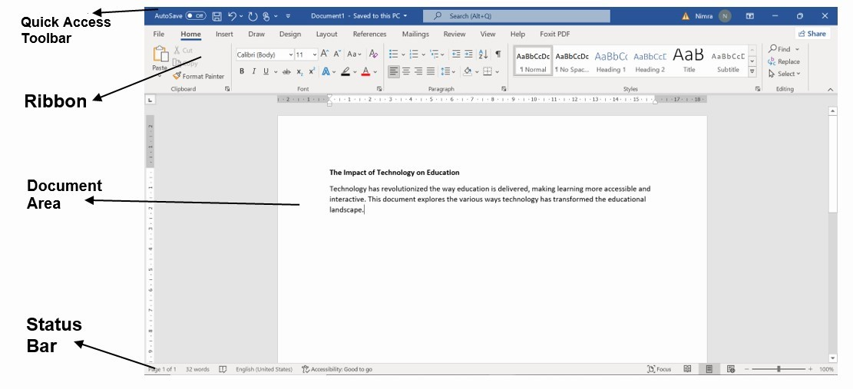
Figure 1: window of Microsoft Office Word
  - Explore the Ribbon: the toolbar at the top containing Home, insert, Layout, Design and more.
  - Quick Access Toolbar: Located above the Ribbon, it provides shortcuts to commonly used commands (e.g., Save, Undo, Redo).
  - Document Area: The main area where you’ll type and edit your content. iv. Status Bar: At the bottom, it shows page number, word count, and view options.
- Now Click in the document area and start typing.
II. To open an existing document:
You can also open an already existing (present in your PC) word document.
- Click the File tab. This takes you to Backstage view.
- Select Open. The Open dialog box appears.
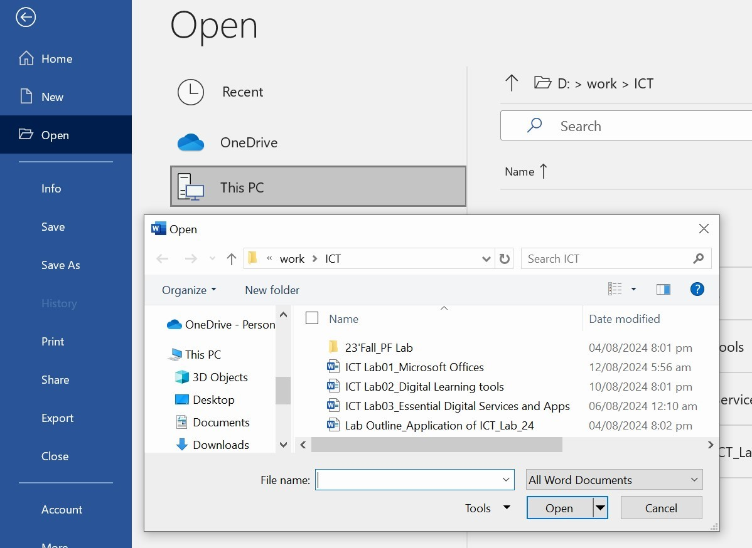
- Select your document, then click Open.
If you've opened a file recently, you can also access it from the Recent Documents list. Just click on the File tab and select Recent.
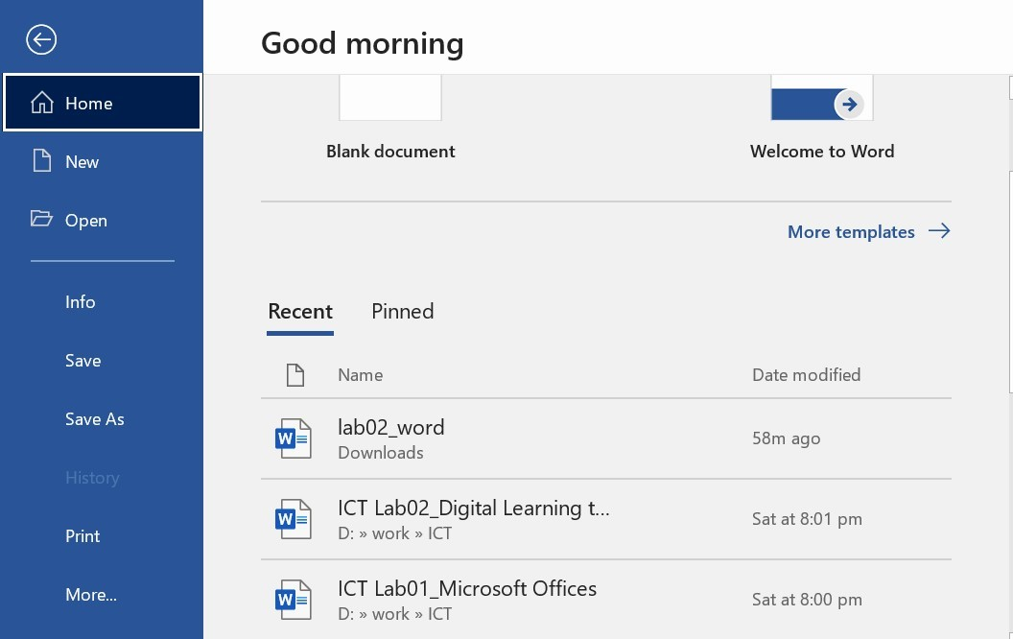
III.To find text in word document:
- From the Home tab, click the Find command. The navigation pane will appear on the left side of the screen.
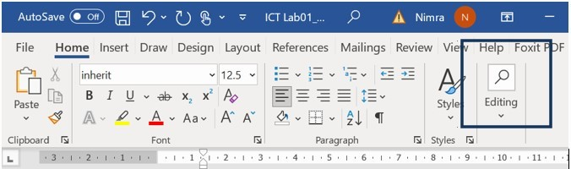
- Type the text you want to find in the field at the top of the navigation pane.
- If the text is found in the document, it will be highlighted in yellow, and a preview will appear in the navigation pane.
IV.To replace text in word document:
- From the Home tab, click the Replace command. The Find and Replace dialog box will appear.
- Type the text you want to find in the Find what field.
- Type the text you want to replace it with in the Replace with field.
- Click Find Next and then Replace to replace text. You can also click Replace All to replace all instances within the document.
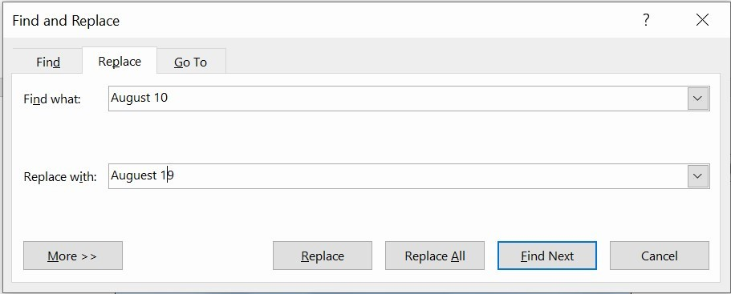
Task 1: Find how many times the word “ICT” is used in this document? Can you replace it by “Information and communication technology” in the whole text.
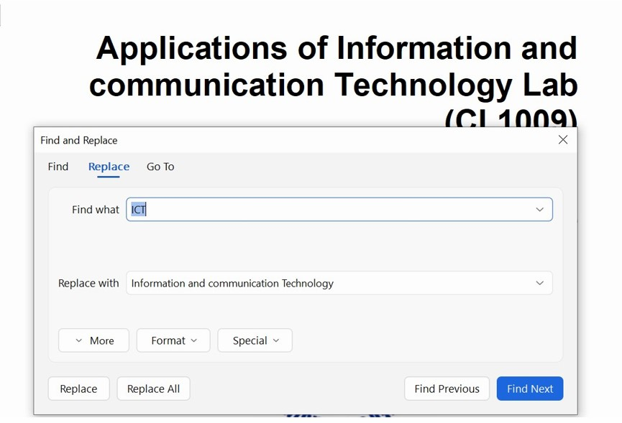

V. Formatting text
Formatted text can emphasize important information and help organize your document. In Word, you have several options for adjusting the font of your text, including size, color, and inserting special symbols. You can also adjust the alignment of the text to change how it is displayed on the page.
To change the font size:
- Select the text you want to modify.
- Click the drop-down arrow next to the Font Size box on the Home tab and Select the desired font size.
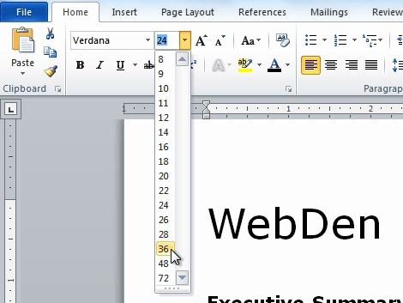
You can also use the Grow Font and Shrink Font commands to change the size.
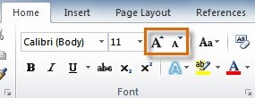
To change the font:
- Select the text you want to modify.
- Click the drop-down arrow next to the Font box on the Home tab. The Font dropdown menu appears.
- Move the mouse pointer over the various fonts. A live preview of the font will appear in the document.
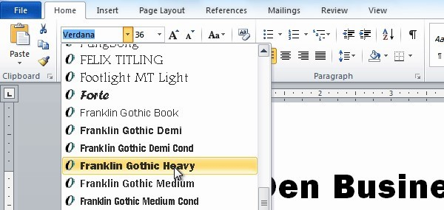
To change the font color:
- Select the text you want to modify.
- Click the Font Color drop-down arrow on the Home tab. The Font Color menu appears.
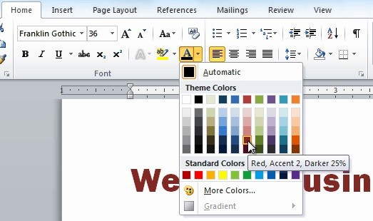
Your color choices aren't limited to the drop-down menu that appears. Select More Colors at the bottom of the list to access the Colors dialog box. Choose the color you want, then click OK.
To highlight text:
- From the Home tab, click the Text Highlight Color drop-down arrow. The Highlight Color menu appears.
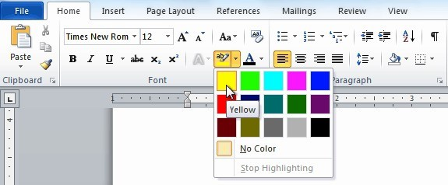
- Select the text you want to modify. It will then be highlighted.
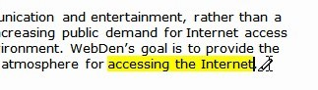
To use the bold, italic, and underline commands:
- Select the text you want to modify.
- Click the Bold, Italic, or Underline command in the Font group on the Home tab.
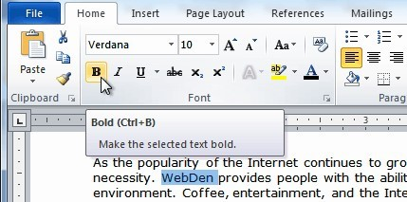
To change text case:
- Select the text you want to modify.
- Click the Change Case command in the Font group on the Home tab.
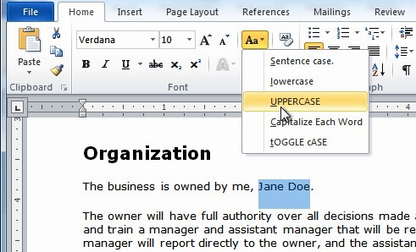
To change text alignment:
- Select the text you want to modify.
- Select one of the four alignment options from the Paragraph group on the Home tab.
  - Align Text Left: Aligns all selected text to the left margin o Center: Aligns text an equal distance from the left and right margins o Align Text Right:
Aligns all selected text to the right margin
  - Justify: Aligns text equally on both sides and lines up equally to the right and left margins; used by many newspapers and magazines
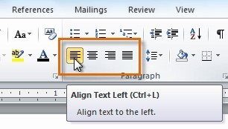
Task 2: Write a summary about your first day at the university. Align the text centrally and highlight the heading, then apply the "Toggle Case" option to the heading. Make sure- the text is written in red color, and use a highlighter of a different color to emphasize key parts of the text.

mY FIRST dAY AT uNIVERSITY
My first day at university went very well. On the second day, I felt a little pressure, but then I became comfortable. After that, I met my teachers. They were very kind, experienced, and helpful. I also talked with my friends and learned many new things from them. My first classes were also very good. Inshallah, I hope that we will have a great and successful life at this university in the future.

VI.Page Layout
Page layout in a Word document allows you to control the appearance of your pages, including margins, orientation, and paper size.
To change page orientation:
- Select the Layout tab.
- Click the Orientation command in the Page Setup group.
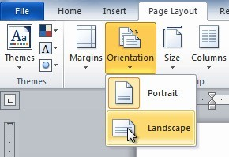
Application of ICT LAB | NUCES, Peshawar | Page 10 of  11
- Click either Portrait or Landscape to change the page orientation.
Landscape format means the page is oriented horizontally, while portrait format means it is oriented vertically.
To change page size:
- Select the Page Layout tab.
- Click the Size command, and a drop-down menu will appear. The current page size is highlighted.
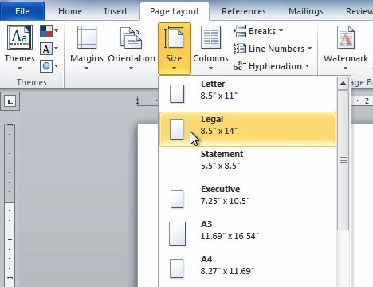
- Click the size option you want. The page size of the document changes.

VII. Paragraph formatting
Indent
Indenting in a Word document allows you to adjust the position of a paragraph relative to the page margins, helping to create a visually structured and organized layout.
To create or adjust a first-line indent or hanging indent:
Application of ICT LAB | NUCES, Peshawar | Page 11 of  11
- Place the insertion point anywhere in the paragraph you want to indent, or select one or more paragraphs.
- To adjust the first-line indent, drag the first-line indent marker on the ruler.
- To adjust the hanging indent, drag the hanging indent marker.
- To move both markers at the same time, drag the left indent marker. This will indent all lines in the paragraph.
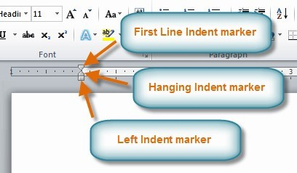
To use the Indent commands:
If you want to indent all lines in a paragraph, you can use the Indent commands on the Home tab.
- Select the text you want to indent.
- Click the Increase Indent command to increase the indent by increments of 1/2 inch.
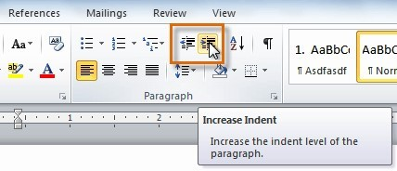
- Click the Decrease Indent command to decrease the indent by 1/2 inch
- To type indent amounts, use the Indent fields on the Page Layout tab.
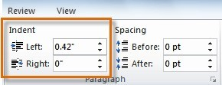

Task 3: For the given paragraph below:
  - Align it centrally.
  - Apply a first-line indent to the paragraph.
  - Use the Increase Indent command to adjust the indent for one of the paragraphs.
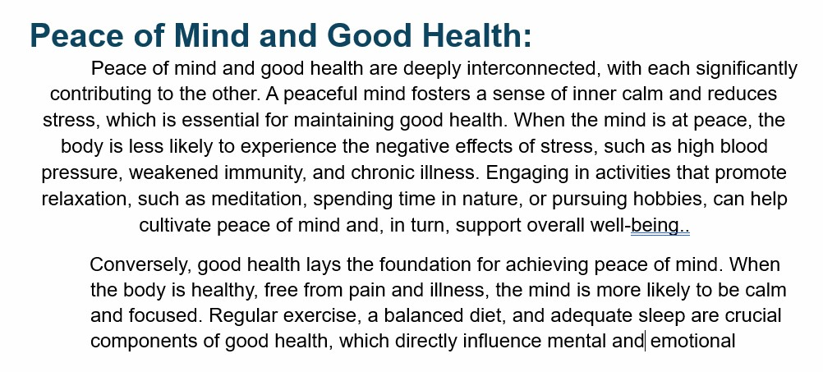
VIII. Using bulleted and numbered lists
When you want to organize lists in Word, you can format them as either bulleted or numbered lists.
Word offers a variety of bullet options that allow you to customize your lists to suit your needs.
To create a list:
- Select the text you want to format as a list.
- Click the Bullets or Numbering drop-down arrow on the Home tab.
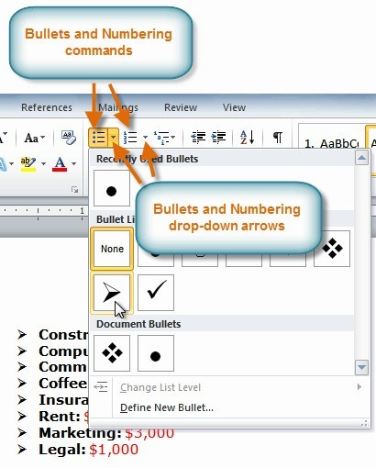
To use a symbol as a bullet: Select an existing list.
- Click the Bullets drop-down arrow.
- Select Define New Bullet from the drop-down menu. The Define New Bullet dialog box appears.
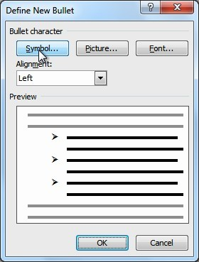
- Click the Symbol button. The Symbol dialog box appears.
- Click the Font drop-down box, and select a font. The Wingdings and Symbol fonts are good choices because they have many useful symbols.
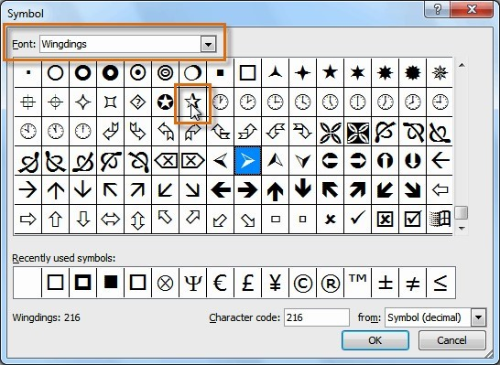
- Select the desired symbol, and click OK.
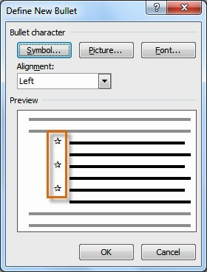
- Click OK to apply the symbol to the list in the document.
You can use a picture as a bullet. Click the Picture button in the Define New Bullet dialog box, then locate the image file on your computer.
To change the bullet color:
- Select an existing list and click the Bullets drop-down arrow.
- Select Define New Bullet from the list. The Define New Bullet dialog box appears.
- Click the Font button. The Font dialog box appears.

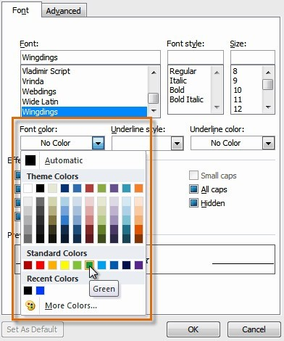 |  |  | LAB: 01
  Introduction to Microsoft Offices
4. Click the desired color to select it and click OK.  Task 4:  Add bullet to the following list and also change the color of the bulle Fruit List:  Banana  Apple  Mango  Peach  Grapes  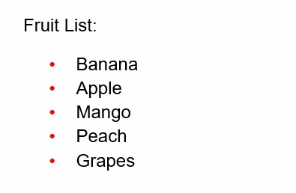 |  |  | ts.  Multilevel lists
 | Application of ICT LAB | NUCES, Peshawar | Page 16 of
 |  |  | 11
Multilevel lists allow you to create an outline with multiple levels. In fact, you can turn any bulleted or numbered list into a multilevel list by placing the insertion point at the beginning of a line and pressing the Tab key to change the level for that line.
To create a multilevel list:
- Select the text you want to format as a multilevel list.
- Click the Multilevel List command on the Home tab.
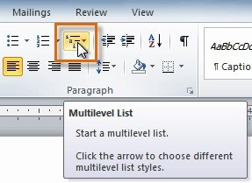
  - Click the bullet or numbering style you want to use. It will appear in the document.
  - Position your cursor at the end of a list item, then press the Enter key to add an item to the list.
Task 5: Write the names of three computer-related software programs and three hardware components related to a computer. Add a picture of a computer in the bullet. Use the multilevel list concept here too.
️ Computer
  - Power Point
  - Design and Media
  - Communication
Software
  - Apps
  - Window
  - Game
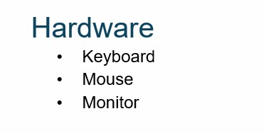
IX. Using shapes
To use shapes effectively, you'll need to know how to insert a shape and format it by changing its fill color, outline color, and shape style, as well as add 3D effects.
To insert a shape:
  - Select the Insert tab.
  - Click the Shapes command.
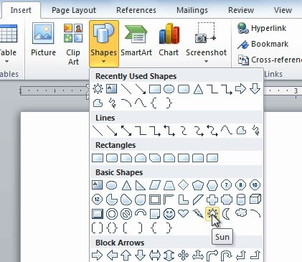
  - Select a shape from the drop-down menu.
  - Click and drag the mouse until the shape is the desired size. Also you can change the orientation of the shape. 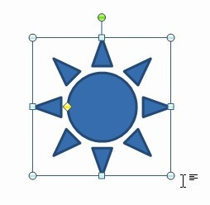
  - Release the mouse button.
To change the order of shapes:
  - Right-click the shape you want to move.
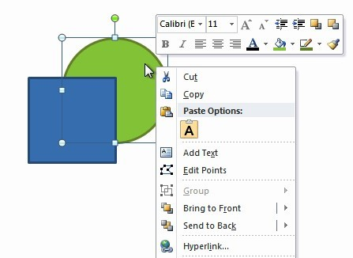
  - In the menu that appears, hover over Bring to Front or Send to Back. Several ordering options will appear.
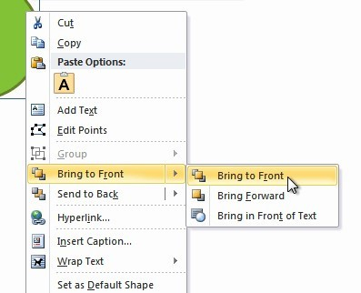
  - Select the desired ordering option. The shapes will reorder themselves.
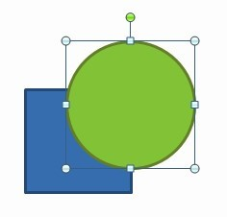
X. Inserting images
Adding pictures to your document can be a great way to illustrate important information or add decorative accents to existing text.
Inserting an image to word document:
  - Place your insertion point where you want the image to appear.
  - Select the Insert tab.
  - Click the Picture command in the Illustrations group. The Insert Picture dialog box appears.
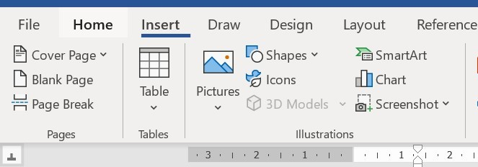
  - Select the desired image file, then click Insert to add it to your document.
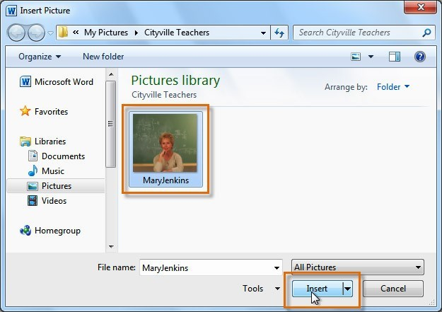
To resize an image, click and drag one of the corner sizing handles. You can also add caption to the image by right clicking on the image and selecting insert caption.
Change Text Wrapping around images:
  - Select the image.
  - Go to the Format tab.
  - Click Wrap Text in the Arrange group.
  - Choose the desired wrapping option.
  - Move the image to see how the text wraps around it.
Insert Caption:
    - Click the picture you want to add a caption to.
    - Click References > Insert Caption or right click on the picture.
    - use the default label (Figure), type your caption in the Caption box.
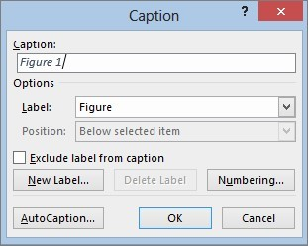
Task 6: Add an image of application of ICT below and add caption to the image.
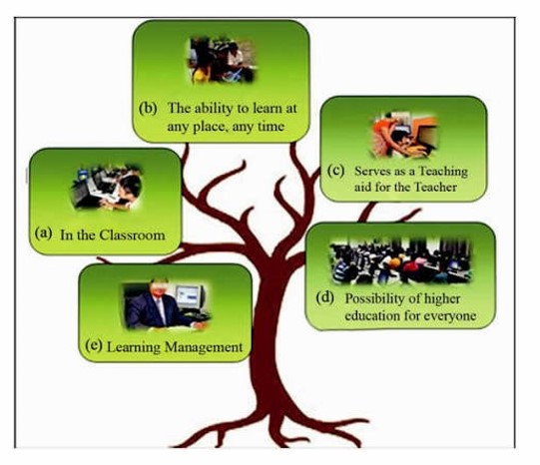

Figure
1
Application of ICT in Education
XI. Using styles
Word's
large
selection
of
styles

and
themes

allows
you
to
quickly
improve
the
appearance
of
your
document.
Styles
can
give
your
document
a
more
sophisticated
look,
while
themes
are
a
great
way
to
change the tone of your entire document quickly and easily.
To select a style:
1.
Select the text you want to format.
2.
In
the
Style

group
on
the
Home

tab,
hover
over
each
style
to
see
a
live
preview
in
the
document. Click the
More
drop-down arrow to see additional styles.
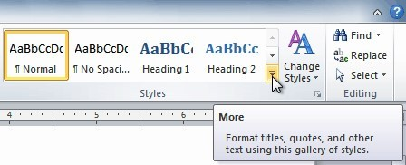
  - Select the style you want. The selected text appears formatted in the style.
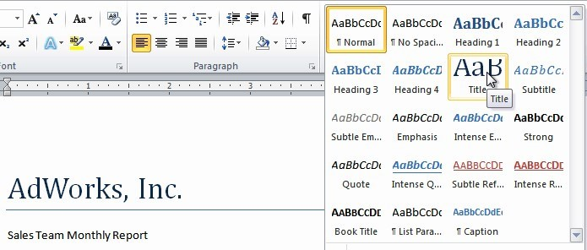
XII.Headers and footers
Headers and footers can help keep longer documents organized and make them easier to read. Text entered in the header or footer will appear on each page of the document.
To insert a header or footer:
  - Select the Insert tab.
  - Click either the Header or Footer command. A drop-down menu will appear.
  - From the drop-down menu, select Blank to insert a blank header or footer, or choose one of the built-in options.
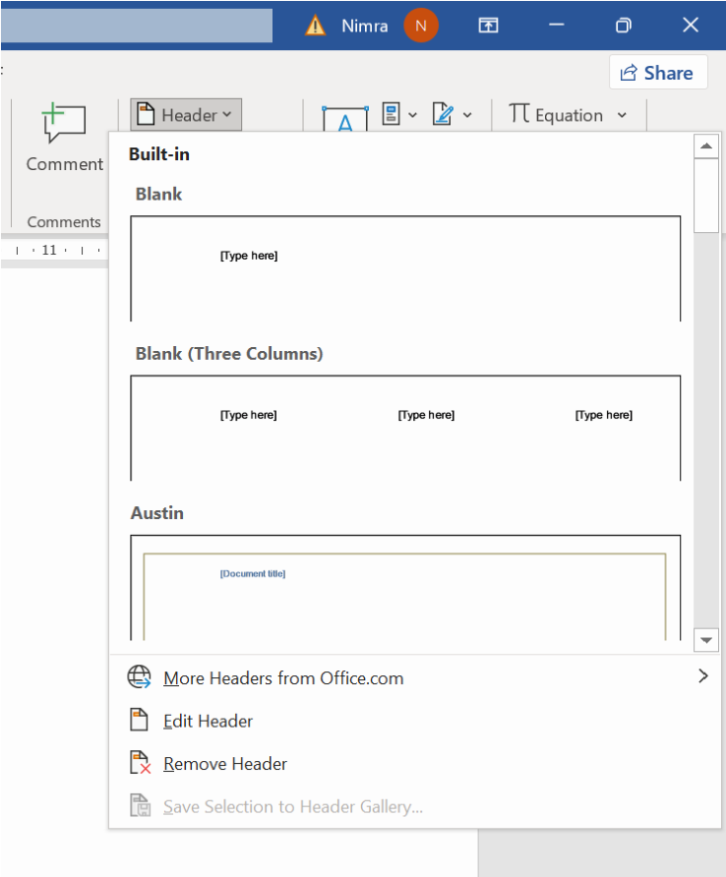
  - When you're finished, click Close Header and Footer in the Design tab, or hit the Esc key.
XIII. Inserting and modifying tables
In Word, tables are useful for organizing and presenting data. You can create a blank table, convert text to a table, and apply a variety of styles and formats to existing tables.
To insert a blank table:
  - Place your insertion point in the document where you want the table to appear.
  - Select the Insert tab.
  - Click the Table command.
  - Hover your mouse over the diagram squares to select the number of columns and rows in the table.
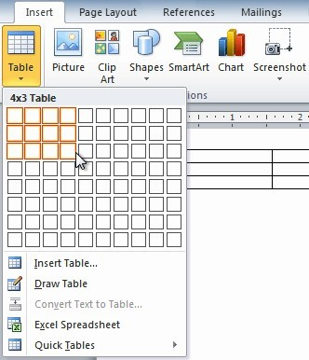
  - Click your mouse, and the table appears in the document.
  - You can now place the insertion point anywhere in the table to add text.
Task 7: Edit the table given below by adding a new row and also change the table design.

Name | Age | Country
Ali Sher | 22 | Pakistan
John | 38 | America
Abishek | 21 | India
Asfandyar | 18 | Pakistan

XIV. Equations
Adding equations to a Word document is straightforward and can be done using the built-in equation editor.
Adding an equation to the document
        - Click where you want to insert the equation in your document.
        - Click on the Insert tab in the ribbon.
        - Click on Equation in the Symbols group. A dropdown menu will appear.
        - You
can either choose a pre-built equation or select Insert New Equation to create a custom one.
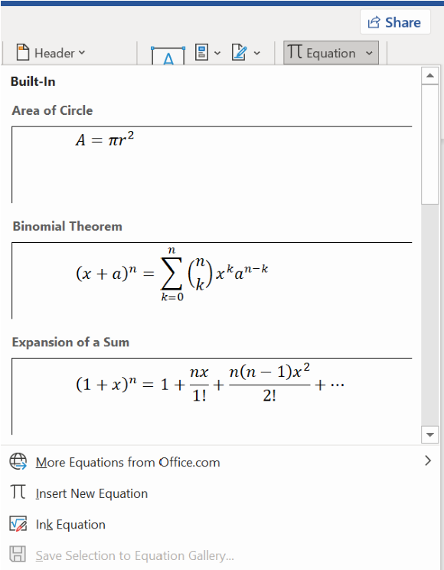
        - If you choose to insert a new equation, a placeholder will appear in the document.
        - You can now type your equation using the provided equation tools. Word will automatically format the text as an equation.
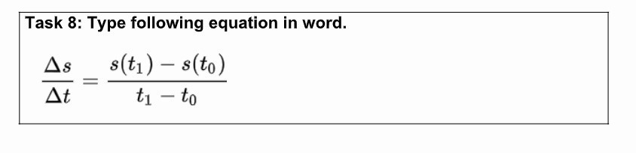
XV.Table of Contents:
Adding a Table of Contents (TOC) in Microsoft Word is simple and helps organize your document by listing the headings and their corresponding page numbers.
Inserting Table of Contents
          - Click where you want to insert the TOC (usually at the beginning of the document).
          - Click on the References tab in the ribbon.
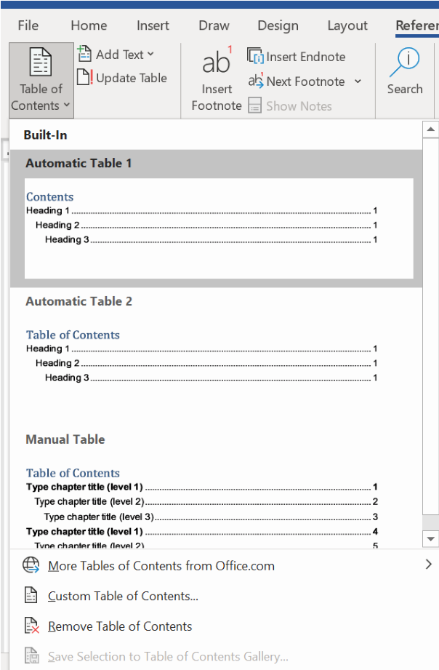
          - Click
on Table of Contents in the Table of Contents group.
          - Choose an automatic TOC style from the dropdown menu. Word will generate a TOC based on the headings you've applied.
          - Click on "Custom Table of Contents." A new screen will appear, allowing you to select the sublevels as well.
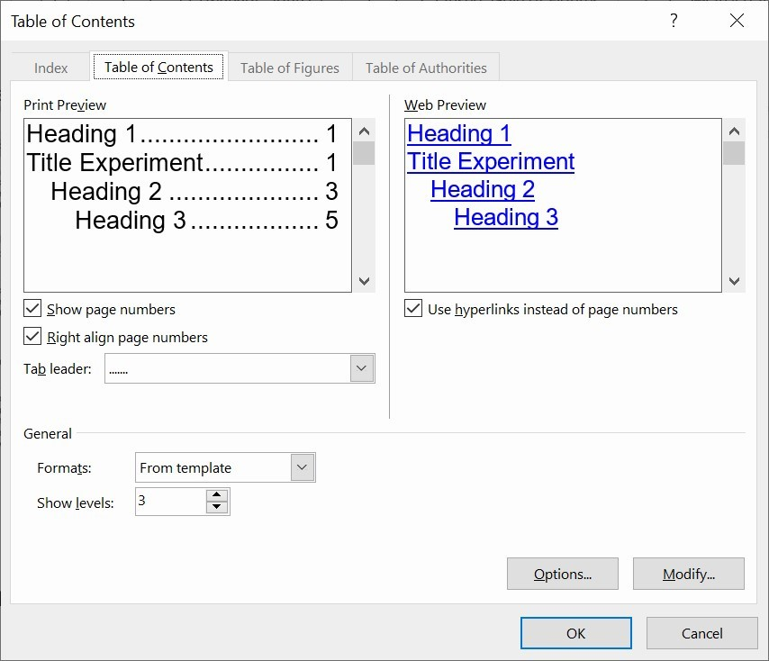
XVI. Saving the document:
1. Now save your document
i. Click File > Save As ii. Double click on This PC (you can also save on one Drive), a new screen will appear. iii. Choose a location, and save your document with an appropriate name.
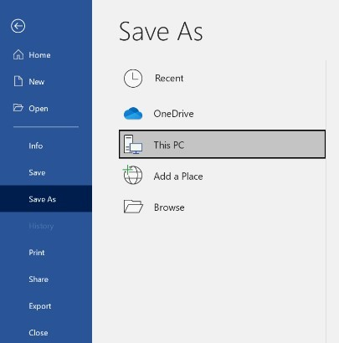
Figure 3: Saving the word document
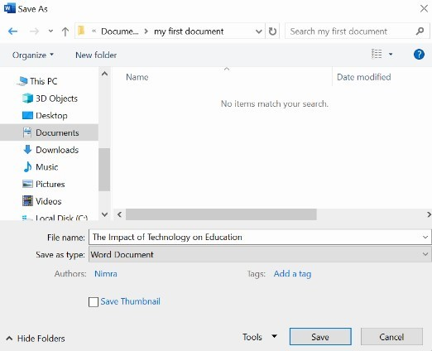
Figure 4: Selecting location and choosing name of the document
Important Tip # 2:
Develop a habit of pressing Ctrl+S or click File-->click Save whenever you make changes to your code, because if you do not do so and the computer accidentally shuts down you will lose work done since the last save command.
XVII. Reviewing documents
Let's say someone asks you to proofread a report. If you have a hard copy of the report, you might use a red pen to cross out sentences, mark misspellings, or add comments in the margins. However, you could also do all of these things in Word using the Track Changes and Comments features.
Tracking Changes
When you turn on the Track Changes option, all changes you make to the document show up as colored markups. If you delete some text, it won't disappear but instead will have a visible strike through it. If you add text, it will be underlined. This allows another person to see which changes have been made before making the changes permanent.

The color of the markups will vary depending on who is reviewing the document, so if there are multiple reviewers, you'll be able to tell at a glance who made each change.
To turn on Track Changes:
- Click the Review tab.
- Click the Track Changes command. It should now be highlighted in gold to show that it is active.
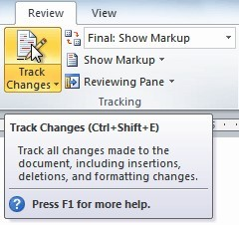
- Any changes you make to the document will be shown as colored markups.
- Click the Track Changes command again to turn it off.
Adding and deleting comments
Sometimes instead of changing something, you may want to make a comment about part of the document. Comments show up in balloons in the right margin and can be read by the original author or by any other reviewers.
To add a comment:
1.
Highlight some text, or place the insertion point where you want the comment to appear.
- From the Review tab, click the New Comment command.
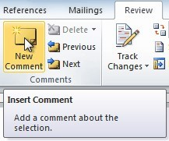
- Type your comment.
To delete a comment:
- Select the balloon containing the comment you want to delete.
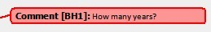
- From the Review tab, click the Delete command.
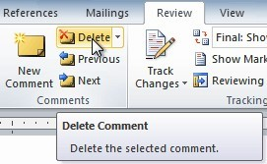

Microsoft PowerPoint
Microsoft PowerPoint is a presentation software that enables users to create slideshows composed of text, images, videos, charts, and animations. It's widely used for creating and delivering presentations for business, educational, and personal purposes, offering a range of tools to design professional and engaging visual content.

I. Creating and exploring a new Presentation:
I. Go to the search bar at the bottom left, type 'Power,' and select Microsoft PowerPoint. II. Once you have opened the document, a slide will appear.
- Ribbon: The toolbar at the top with tabs like Home, Insert, Design, Transitions, and more.
- Slides Pane: On the left side, it shows a thumbnail view of all your slides. iii. Slide Area: The central area where you edit and design individual slides. iv. Notes Pane: At the bottom, where you can add notes for each slide.
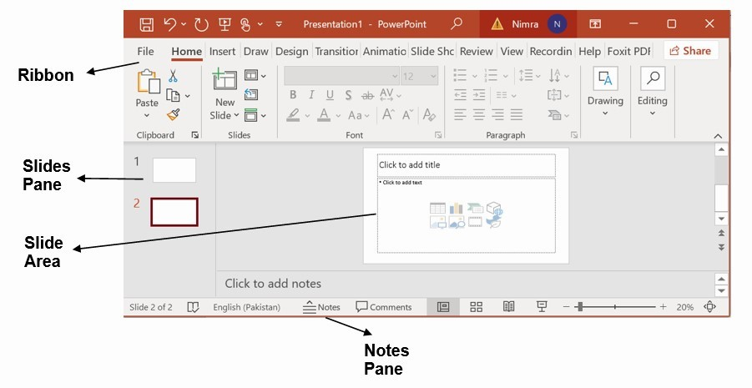
Figure 5: PowerPoint Slide
- Select a built-in template or theme from the Design tab to start with a pre-designed layout.
Or opt for a blank presentation to start from scratch if you prefer.
- Click on the Home tab and select New Slide to add slides.
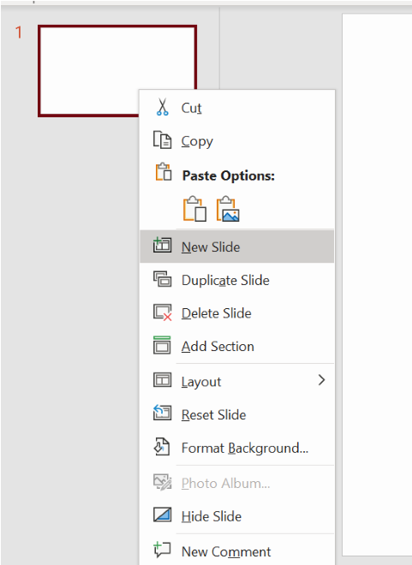

II. To open an existing presentation:
- Click the File tab. This takes you to Backstage view.
- Select Open. The Open dialog box appears.
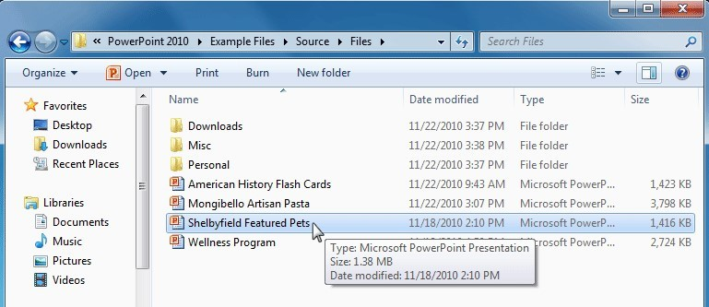
- Select your desired presentation, then click Open.
III.Slide
Layout
Placeholders are arranged in different layouts that can be applied to existing slides or chosen in a new slide. A slide layout arranges content using different types of placeholders, depending on what information you might want to include in your presentation.
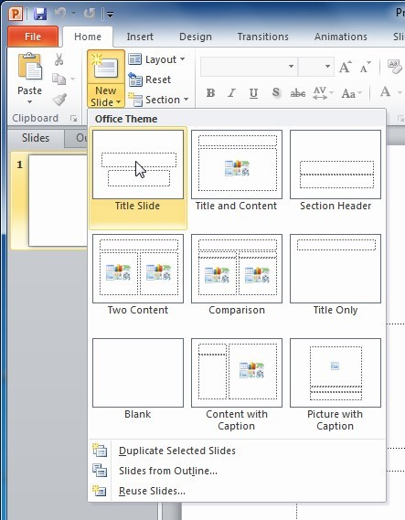
To change the layout of an existing slide:
- Select the slide you want to change.
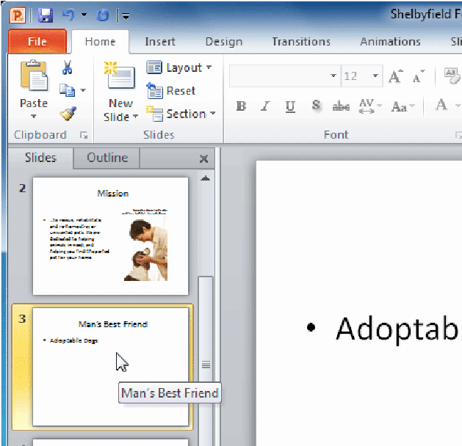
- Click the Layout command in the Slides group on the Home tab. A menu will appear with your options.
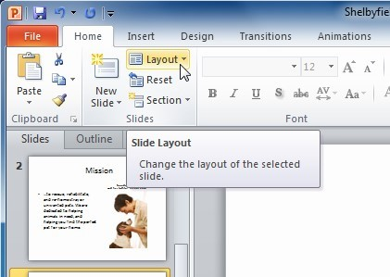
- Choose a layout from the menu. The slide will change in the presentation.
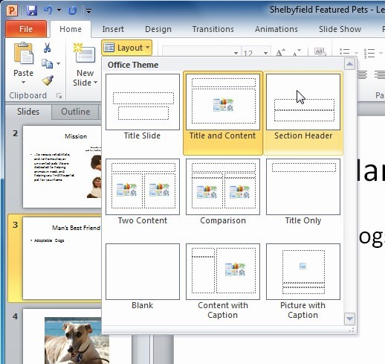

IV.Slide views
The slide view commands are located on the bottom-right of the PowerPoint window.
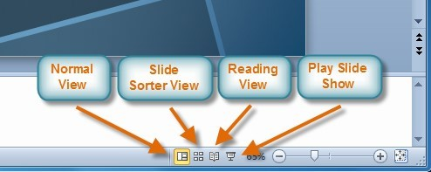
Normal view: This is the default view where you create and edit your slides. You can also move slides in the Slides tab in the pane on the left.
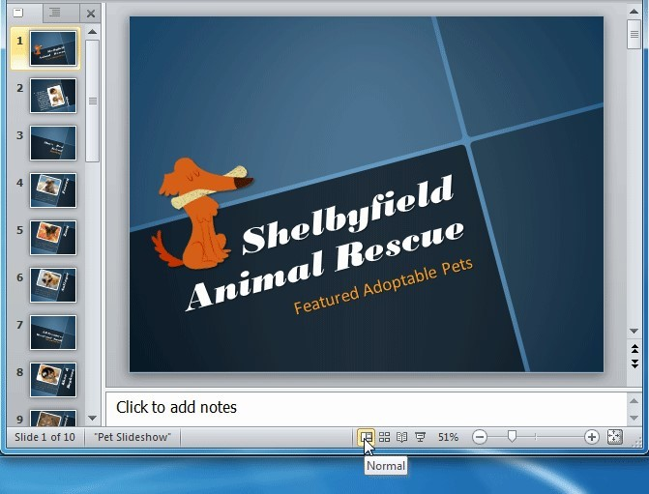
Slide Sorter view: In this view, miniature slides are arranged on the screen. You can drag and drop slides to easily reorder them and to see more slides at one time.
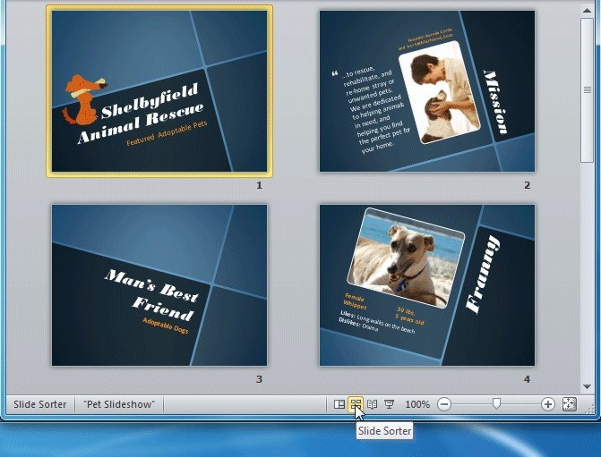
Reading view: This view fills most of the computer screen with a preview of your presentation. Unlike Slide Show view, it includes
easily accessible buttons for navigation, located at the bottom-right.

Slide Show view: This view completely fills the computer screen and is what the audience will see when they view the presentation.

Press the Esc key to end the slide show.

V. Adding notes to slides
PowerPoint gives you the ability to add notes to your slides—often called speaker notes—to help you deliver or prepare for your presentation.
To use the Notes pane:
- Locate the Notes pane at the bottom of the screen, directly below the Slide pane.
- Click and drag the edge of the pane to make it larger or smaller.
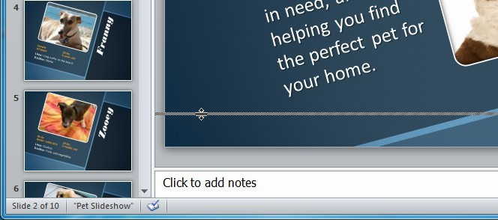
- Type
your notes in the Notes pane.
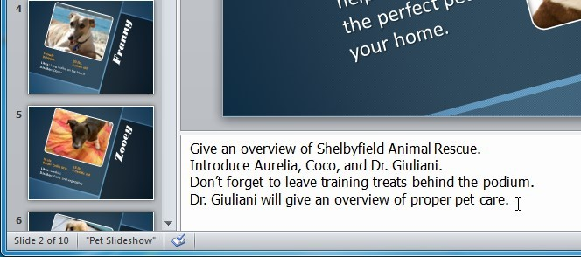

VI.Adding Text
If you're new to PowerPoint, you'll need to learn the basics of working with text so you can add and arrange text on your slides.
To insert text
- Click the placeholder or text box where you want to insert text.
- To delete text, place the insertion point next to the text you want to delete and press the Backspace key.
To add a text box:
Inserting an extra text box allows you to add to the slide layout so you can include as much text as you want.
1. From the Insert tab, click the Text Box command.
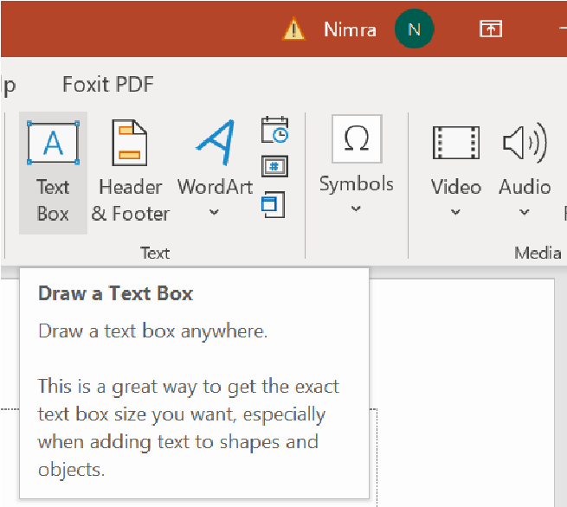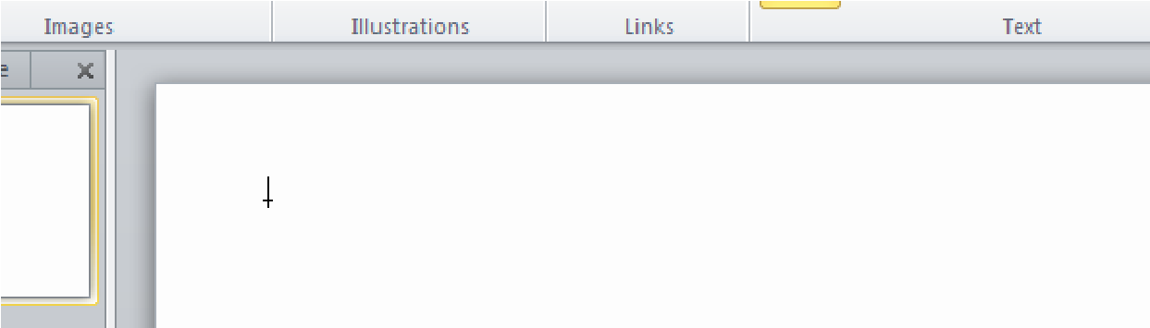
2.
Your cursor will turn into an
upside-down cross
.
3. Click the area on your slide where you want to add a text box. A text box will appear with an insertion point inside.
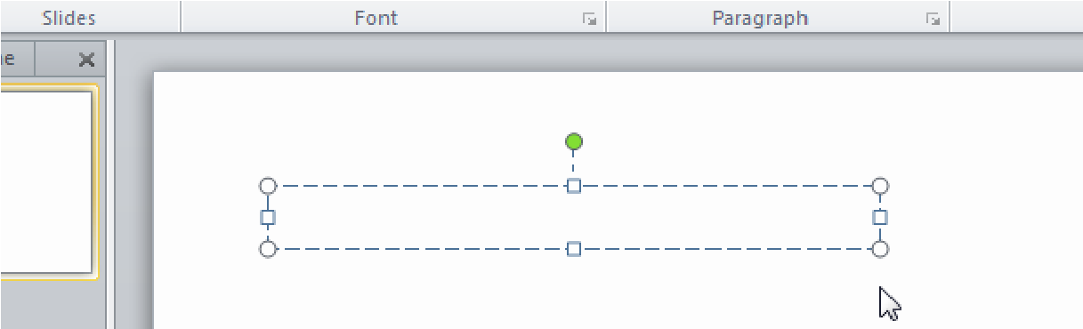

VII. Formatting text
You can help your text stand out on the slide by changing its formatting, including font size, color, and style.
Click the buttons in the interactive below to learn about the different commands in the Font group.
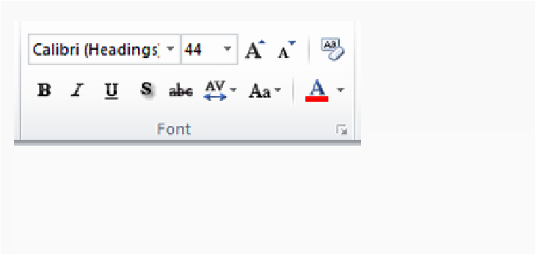
VIII. To insert a bulleted list:
- Select the text box or specific text you want to format as a bulleted list.
- Click the Bullets command in the Paragraph group on the Home tab.
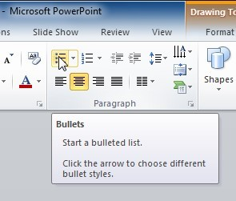
IX.To change horizontal text alignment:
- Select the text you want to modify.
- Select one of the four alignment options in the Paragraph group i.e., Align Text Left, Center, Align Text Right and Justify.
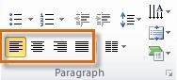
To change vertical text alignment:
- Select the text you want to modify.
- Click the Align Text command in the Paragraph group. A menu will appear.
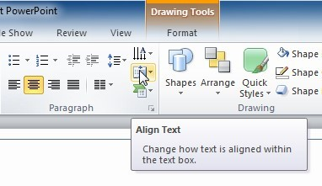
- Choose to align the text at the Top, Middle, or Bottom of the text box.
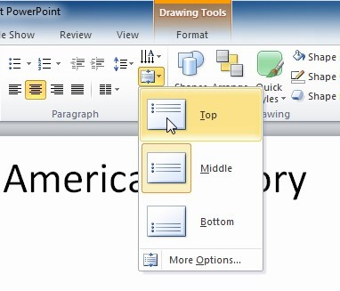
X. To change text direction:
- Select the text you want to modify.
- Click the Text Direction command in the Paragraph group. A menu will appear.
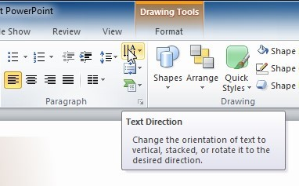
- Choose for the direction of the text to be Horizontal, Rotated, or Stacked.
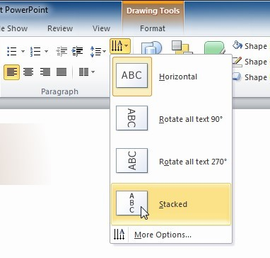

XI.Themes
A theme is a set of colors, fonts, effects, and more that can be applied to your entire presentation to give it a consistent, professional look.
Theme elements
Every PowerPoint theme—including the default Office theme—has its own theme elements. These elements are:
- Theme Colors (available from every Color menu)
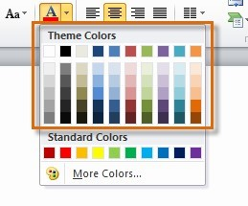
- Theme Fonts (available from the Font menu)
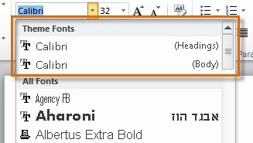
- Shape Styles (available in the Format tab when you click a shape)
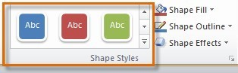
To apply a theme
- Go to the Design tab.
- Locate the Themes group. Each image represents a theme.
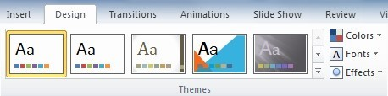
- Hover over a theme to see a live preview of it in the presentation. The name of the theme will appear as you hover over it.
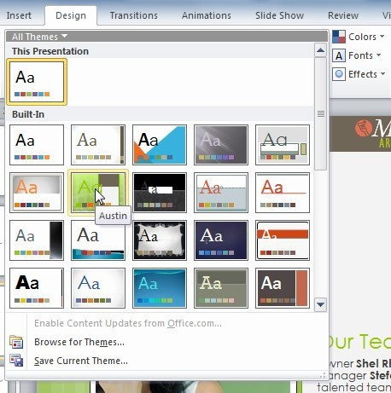
- Click a theme to apply it to the slides.

XII. To insert an image from a file:
- Select the Insert tab.
- Click the Picture command.
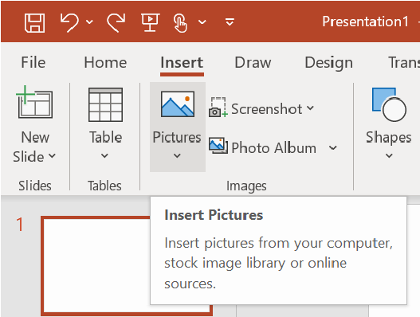
- Select the desired image file, then click Insert.
- The picture will appear in your slide.

XIII. Applying transitions
If you've ever seen a PowerPoint presentation that had special effects between each slide, you've seen slide transitions. A transition can be as simple as fading to the next slide or as complex as a flashy, eye-catching effect.
There are three categories of unique transitions to choose from, all of which can be found on the Transitions tab:
- Subtle (slight transitions)
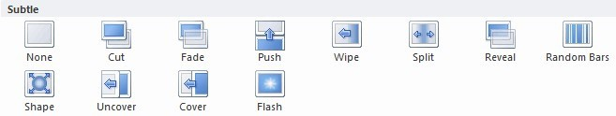
•
Exciting (strong transitions)
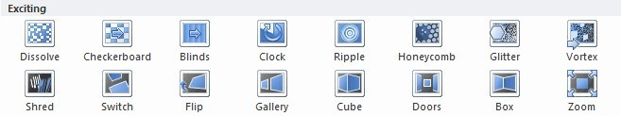
- Dynamic Content (strong transitions that affect only the content, such as text or images)
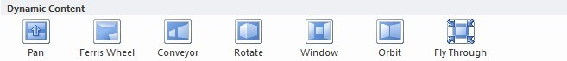
To apply a transition:
- Select the slide you want to modify and click the Transitions tab.
- Locate the Transition to This Slide group. By default, none is applied to each slide.
- Click a transition to apply it to the selected slide. This will automatically preview the transition as well.

XIV. Checking spelling
To make your slide show appear professional, you'll want to make sure it is free from spelling errors.
PowerPoint has several options for checking your spelling. You can run a spell check, or you can allow PowerPoint to check your spelling automatically as you type.
To run a spell check:
- Go to the Review tab.
- Click the Spelling command.
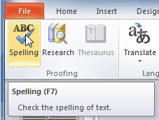
- The Spelling dialog box will open. For each error in your presentation, PowerPoint will try to offer one or more suggestions. You can select a suggestion and then click Change to correct the error.
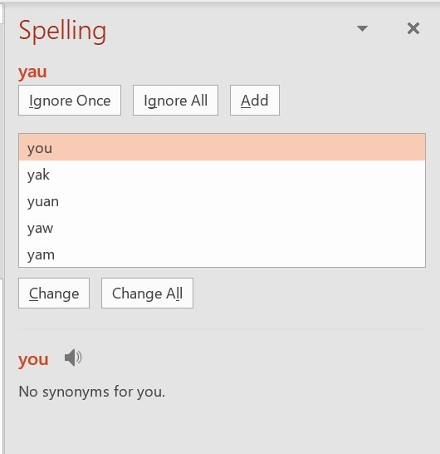
To use the automatic spell check feature:
- Right-click the underlined word. A menu will appear.
- Click the correct spelling of the word from the list of suggestions.
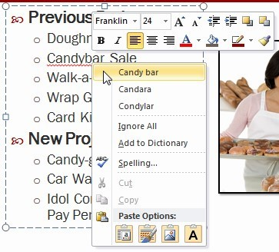
- The corrected word will appear in the presentation.
You can choose to Ignore an underlined word, Add to Dictionary, or go to the Spelling dialog box for more options.
XV. To compress a picture:
- Select the picture. The Format tab will appear.
- Select the Format tab.
- Click the Compress Pictures command in the Adjust group. A dialog box appears.
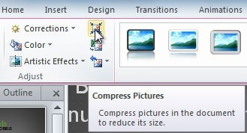
- Place a check mark next to Delete cropped areas of pictures. You can also choose whether to apply the settings to this picture only or to all pictures in the presentation.
- Choose a Target output. If you are emailing your presentation, you may want to select Email, which produces the smallest file size.
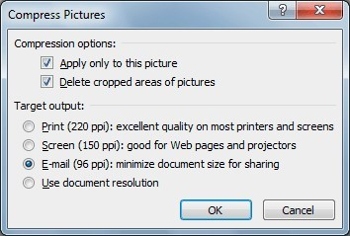

XVI. Aligning objects
You can click and drag objects to align them manually, but guesswork will never give you the best result.
Additionally, aligning objects in this way can take a great deal of time.
To align two or more objects:
- Click and drag your mouse to form a selection box around the objects you want to align. All of the objects will now have sizing handles to show that they are selected.
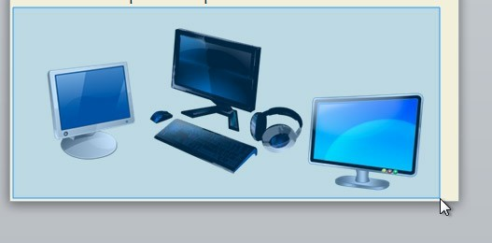
- From the Format tab, click the Align command, and select Align Selected Objects.
- Click the Align command again, and select one of the six alignment options.
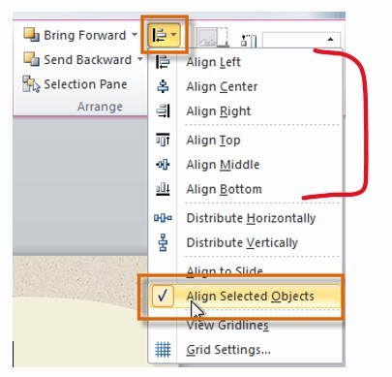
- The objects will align to each other based on the option you have selected.
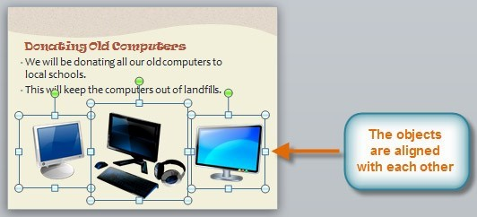
To group objects:
- Click and drag your mouse to form a selection box around the objects you want to align. All of the objects will now have sizing handles to show that they are selected.
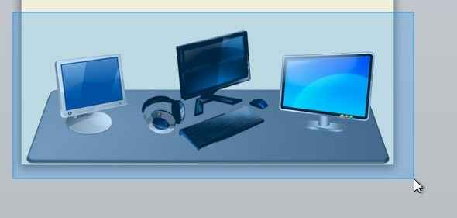
- From the Format tab, click the Group command, then select Group.
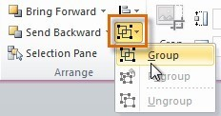
- The selected objects will now be grouped. There will be a single box with sizing handles around the entire group to show that they are one object.

To ungroup objects:
- Select the grouped object you want to ungroup.
- From the Format tab, click the Group command, then select Ungroup.
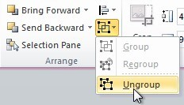

XVII. Animation
PowerPoint offers a variety of animations you can use to enhance your presentation. Animations can be used to make text or objects appear on a slide, exit a slide, or emphasize the text or objects already on a slide.
The four types of animations
- Entrance: This control how the object enters the slide. For example, with the Bounce animation, the object will drop onto the slide and then bounce several times.

- Emphasis: These animations occur while the object is on the slide and are often triggered by a mouse click.

- Exit: This control how the object exits the slide. For example, with the Fade animation, the object will simply fade away.

- Motion Paths: These are similar to Emphasis effects, except the object moves within the slide along a predetermined path, like a circle.
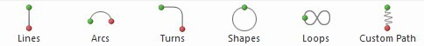
To apply an animation to an object:
- Select an object.
- Click the Animations tab.
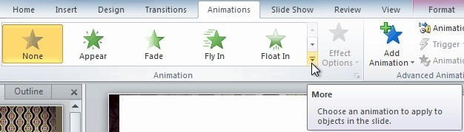
- Select the desired animation effect.
- At the bottom of the menu, you can access even more effects.
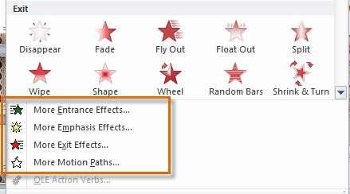

XVIII. Inserting videos
Adding a video to your presentation can help emphasize certain points and provide an example. Once you add a video, you can edit it and format its appearance.
To insert a video from a file on your computer:
1. From the Insert tab, click the Video drop-down arrow and select Video from File.
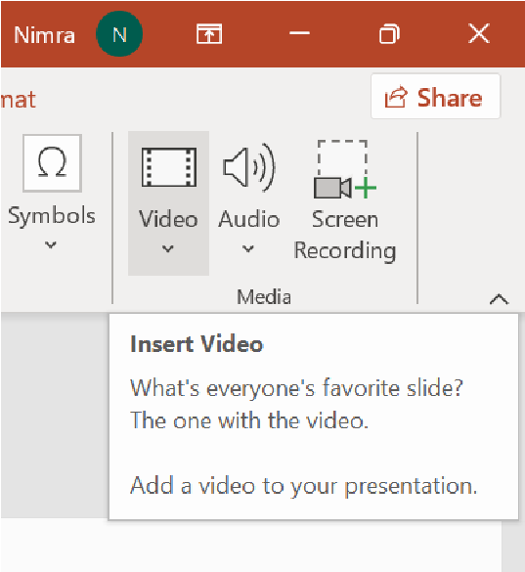
2.
Locate and
select the desired video file, then click Insert.
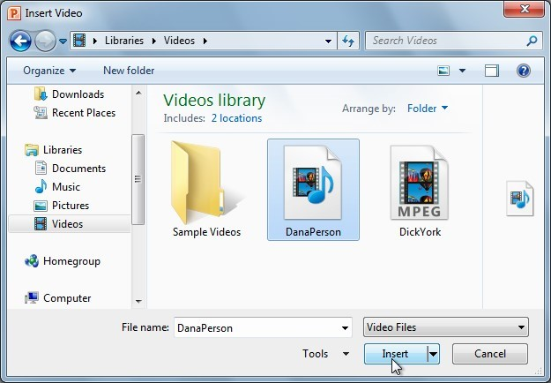
3. The video will be added to the slide.
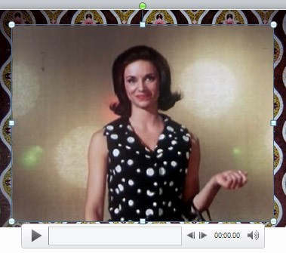
To preview the video:
- Make sure the video is selected.
- Click the Play/Pause button below the video. The video will start playing, and the timeline next to the Play/Pause button will begin to advance.
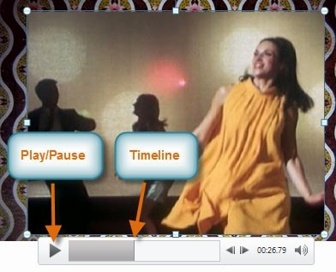
- To
jump to a
different part of the video, click anywhere on the timeline.
To trim the video:
- From the Playback tab, click the Trim Video command. The Trim Video dialog box will appear.
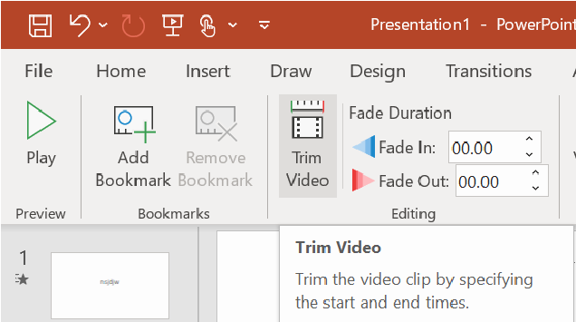
- Use the green and red handles to set the start and end times.
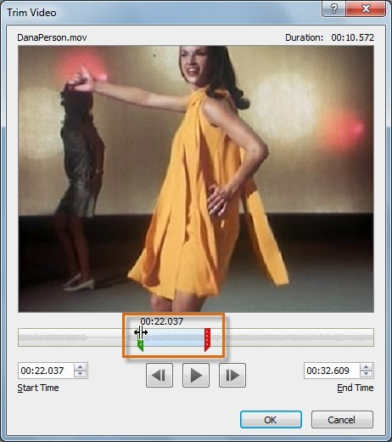
- To preview the video file, click the Play button.
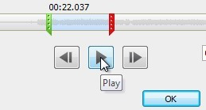
- Adjust the green and red handles again, if necessary, then click OK.

XIX. SmartArt graphics
PowerPoint has a variety of SmartArt graphics you can use to illustrate and organize different types of ideas.
To insert a SmartArt graphic:
- Select the Insert tab.
- Select the SmartArt command in the Illustrations group. A dialog box will appear.
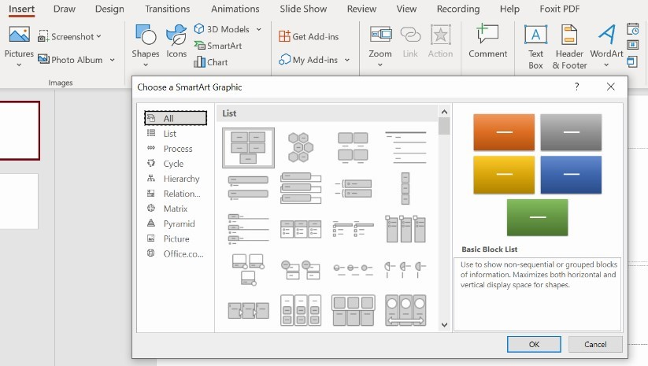
- Select a category on the left of the dialog box and review the SmartArt graphics that appear in the center.
- Select the desired SmartArt graphic, then click OK.

XX. Hyperlinks
Hyperlinks have two basic parts: the address of the webpage, email address, or other location they are linking to; and the display text, which can also be a picture or shape. For example, the address could be https://www.youtube.com and the display text could be YouTube. In some cases, the display text might be the same as the address. When you're creating a hyperlink in PowerPoint, you'll be able to choose both the address and the display text or image.
To insert a hyperlink:
- Select the image or text you want to make a hyperlink.
- Right-click the selected text or image, then click Hyperlink.
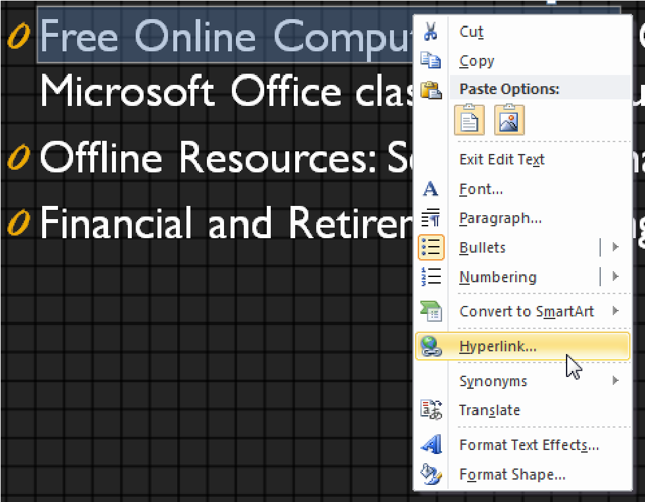
- The Insert Hyperlink dialog box will open. You can also get to this dialog box from the Insert tab by clicking Hyperlink.
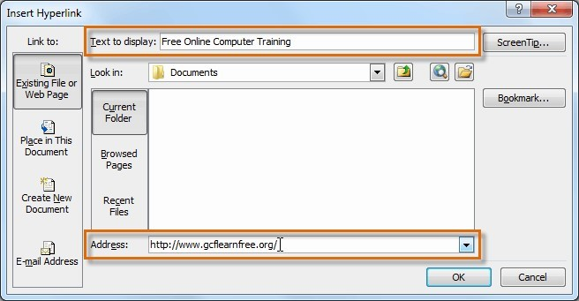
- If you selected text, the words will appear in the Text to display field at the top. You can change this text if you want.
- Type the address you want to link to in the Address field.
- Click OK. The text or image you selected will now be a hyperlink to the web address.

To remove a hyperlink:
- Right-click the hyperlink.
- Click Remove Hyperlink.
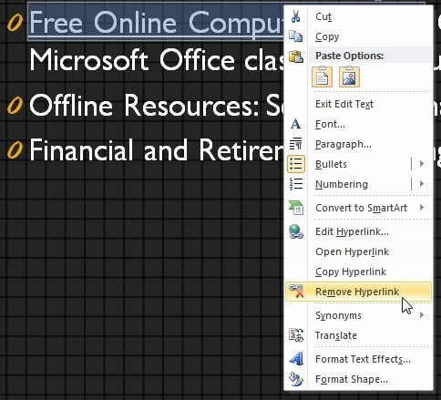
XXI. Saving the document:
2. Now save your document iv. Click File > Save As
v.
Double
click on This PC (you can also save on one Drive), a new screen will appear. vi. Choose a location, and save your document with an appropriate name.
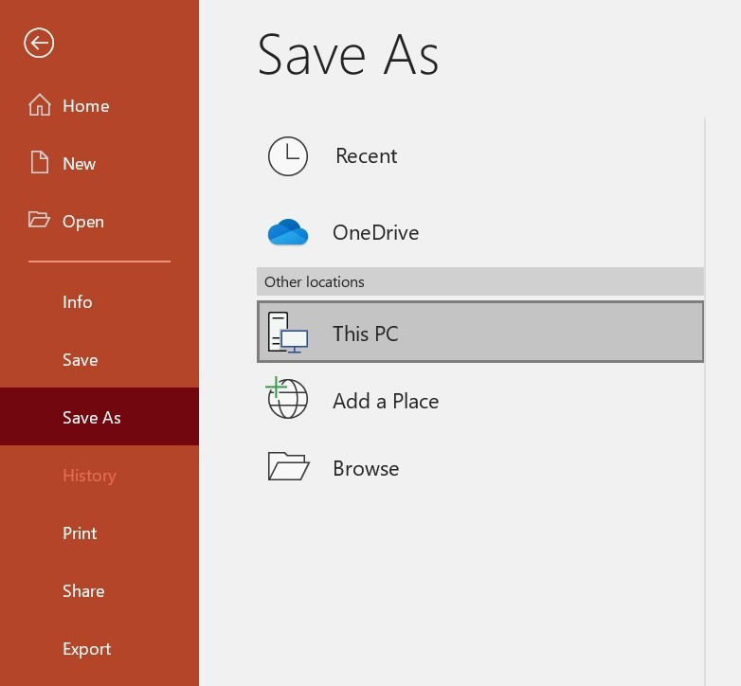
Figure 6: Saving the PowerPoint document
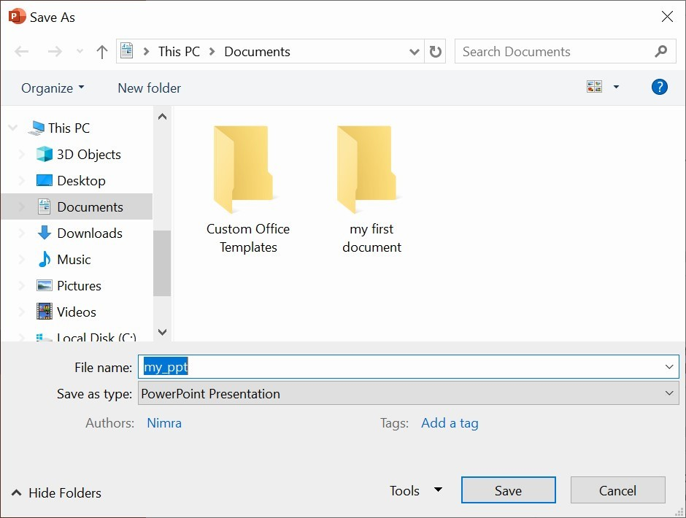
Figure 7: Selecting location and choosing name of the document
Exercise: Task 1:
- Open Microsoft PowerPoint and create a new presentation.
- Create a title slide with a simple title (e.g., “My Favourite Hobbies”).
- Insert an image related to the title of your presentation and adjust it appropriately.
- Add at least 3 content slides, each dedicated to a different hobby (e.g., “Reading,” “Cooking,” “Traveling”).
- For each hobby, include:
  - Text: Write a brief description.
  - Images: Insert at least one relevant image for each hobby. iii. SmartArt: Create a SmartArt graphic to visually represent aspects of each hobby (e.g., steps in a recipe for cooking or locations visited for traveling).
- Choose a professional theme from the Design tab that complements your content.
- Customize the background of each slide with a colour or pattern that enhances the visual appeal of your presentation.
- Customize the SmartArt graphics to match the overall design of the presentation.
- Insert a short video clip (e.g., a video of you cooking or a book review) into one of the content slides.
- Apply a basic transition effect between slides to make the presentation flow smoothly.
- Add a unique transition effect for the title slide to make it stand out.
- Add entrance animations to the text and images on each content slide.
- For each slide, add notes explaining the content, images.


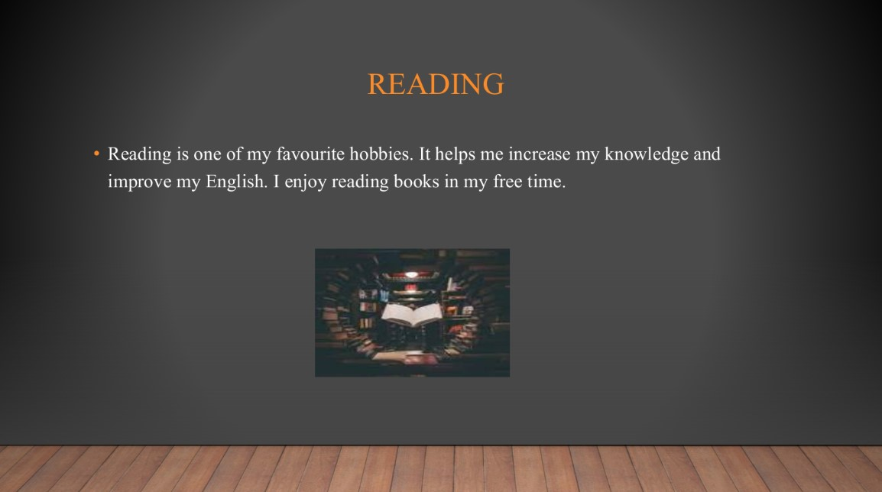



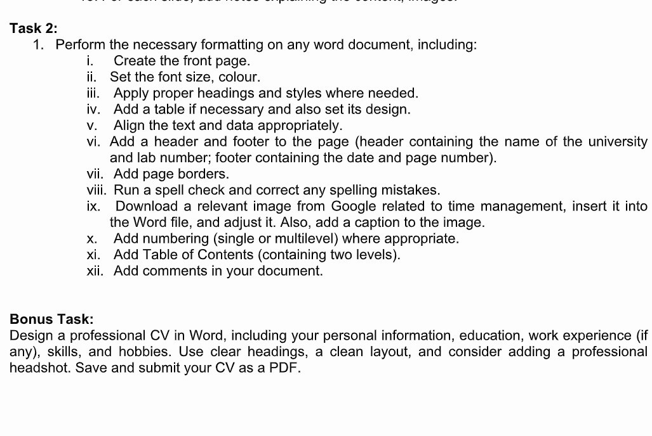

1. Introduction
Time management is the process of planning and organizing how to spend your time. It helps students complete their work on time, reduce stress, and achieve their goals. Good time
Introduction 2 management allows us to balance study, rest, and other activities.
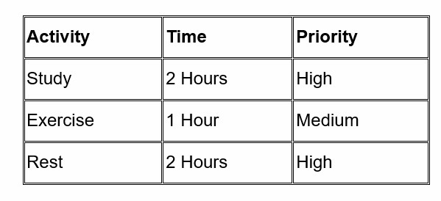

Figure 1 Time Management

2. Importance of management
Time management is important for students because it helps them organize their studies and daily activities. It helps students complete their assignments on time and gives them enough time for study, rest, and other activities.

3. Time Management Techniques

3.1 To-Do List
A to-do list is a list of tasks that a person needs to complete. Students can write their daily tasks and complete them one by one.

3.2 Prioritization
Prioritization means deciding which tasks are more important. Important tasks should be completed first, while less important tasks can be completed later.

3.3 Time Blocking
Time blocking means dividing the day into different time periods for different activities. A student can set specific times for studying, completing assignments, exercise, and rest.

4. Benefits of Time Management
Good time management has many benefits for students. It helps them complete their assignments on time, stay organized, improve their focus, and balance their studies with other activities.
- Complete assignments on time.
- Stay organized.
- Improve focus.
- Reduce unnecessary delays.
- Balance study and rest.

5. Conclusion
Time management is an important skill for students. By using techniques such as to-do lists, prioritization, and time blocking, students can organize their daily activities and use their time effectively.

MICROSOFT POWERPOINT 39 2
Microsoft Office Word 3
mY FIRST dAY AT uNIVERSITY 10
Microsoft PowerPoint 32
I. Creating and exploring a new Presentation: 32
II. To open an existing presentation: 33
V. Adding notes to slides 36
VI.Adding Text 37
XI.Themes 40
XII. To insert an image from a file: 41
1. Introduction 56
2. Importance of management 57
3. Time Management Techniques 57
3.1 To-Do List 57

